BARACK OBAMA
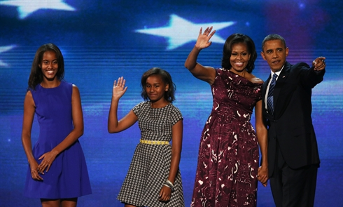
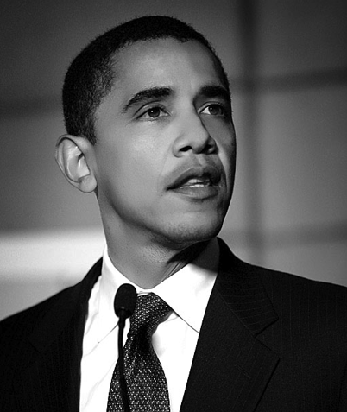
Barack Hussein Obama ,was born August 4th 1961 in Honolulu in Hawai,he is American. He represents the democratic party (the logo is a Donkey ). His wife is Michelle Robinson and he has two daughters, Sasha who is fifteen and Malia who is twelve. Obama is a Graduate of the Faculty of Law ,of the University of Columbia. Also he is protestant. The election is in November 2012.

by Mélodie and Ninon

