Barack Obama

Barack Obama is running for a second mandate for the presidential elections of the USA. In 2008 he was elected the first black president of the USA.

Name : Barack Obama
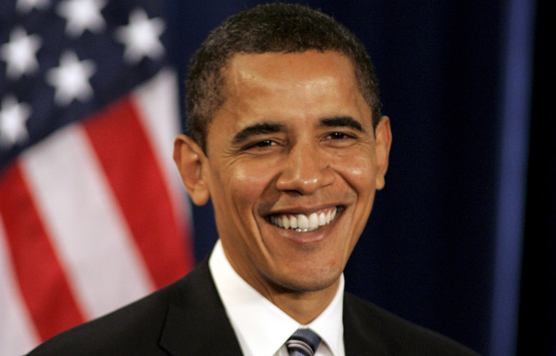
Age : 51 years old
Place of birth : Honolulu,Hawaii,U.S
Nationality : American

Wife : Michelle Robinson
Children : two daughters : Malia and Sasha
Residence : White House ( official )
Chicago, Illinois ( private )
Studies : Occidental College
Columbia College (B.A)
Harvard Law school

Political Party : Democratic Party
Profession : President
His vice president : Joe Biden

Awards : Nobel Peace Prize
Signature :
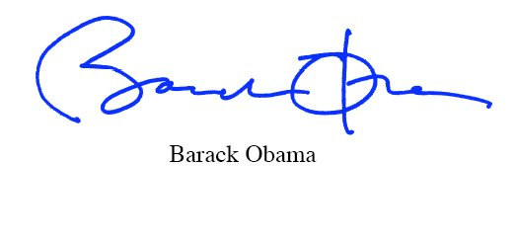

Biography by Baptiste and Timothé

